Q1).

Looking at the graph of the FET characteristics, at the point where I_{D} = 3mA and V_{DS} = 9V

V_{GS} = -3.0V

The potential at the gate of the FET is zero, if V_{GS} is –3.0V then

R_{S} must drop a potential of 3.0V. The current entering the source is I_{D} = 3mA, Hence: -

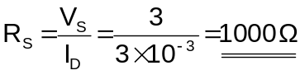
If there is a potential drop across the drain/source V_{DS} of 9V and a potential drop across the source resistor of 3V then: -

Because the source voltage V_{S} = 18V

V_{L} = 18 – 9 – 3 = 6V

Hence: -
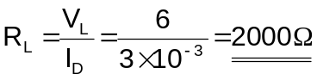

Q2).

From the graphical FET characteristics the drain resistance r_{d} and mutual conductance g_{m} can be solved: -

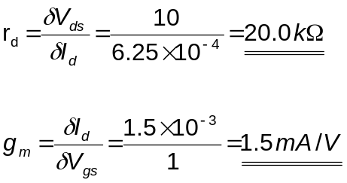

Q3).

R_{G} = 1 x 10⁻⁶ Ω

From Question1: -

R_{d} = R_{L} = 2 kΩ

The AC equivalent circuit for the amplifier at this operating point is: -

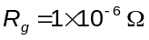
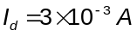
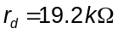
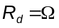

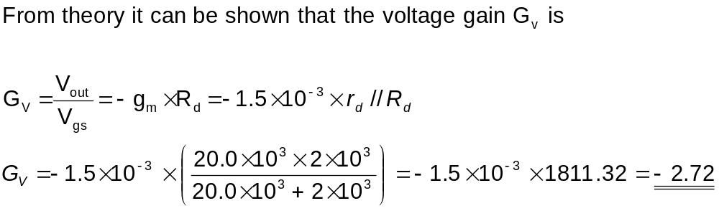

By attaching an exactly similar circuit to the output of the first stage the resulting signal generated at the output of the second stage would be a power of 2 greater than the input to the first.

The gain of the whole amplifier would be: -

G_{v(2 stages)} = - (2.72)² = -7.44

